

# SWE1007

Programming in Java

J-COMPONENT PROJECT SOURCE CODE

#### NAME: MOHAMED RAYAN

#### REG.NO: 20MIS0098

#### SLOT: L51+L52

Chatting Application - NOVA

## MAIN OBJECTIVE:

The aim of this project is to express how we can implement a simple chat application between a server and a client? The application is a desktop based application and is implemented using java Swing, java networking, jdbc and awt. The project is developed in Java language executed on a single stand-alone java across a network using loop back address concept.

**SERVER CODE:**

*package* com.chatting_application;  
  
*import* javax.swing.*;  
*import* java.awt.*;  
*import* java.net.ServerSocket;  
*import* java.net.Socket;  
*import* java.io.*;  
*import* java.sql.*Connection*;  
*import* java.sql.DriverManager;  
*import* java.sql.*ResultSet*;  
*import* java.sql.*Statement*;  
*import* java.lang.*;  
  
  
*import* java.awt.event.MouseAdapter;  
*import* java.awt.event.MouseEvent;  
*import* java.awt.event.*MouseListener*;  
*import* java.text.SimpleDateFormat;  
*import* java.util.Date;  
  
*import* java.awt.event.ActionEvent;  
*import* java.awt.event.*ActionListener*;  
*//=== === === === === === BACKUP MESSAGES === === === === === === === === === === === === === === === === === === === === ===//  
  
class* backup *extends* JFrame {  
  
 JPanel p1;  
 JTextField t1;  
 JButton b1;  
 *static* JTextArea *tf1*;  
 JScrollPane sb;  
 JLabel l5;  
  
  
 *public* backup() {  
  
 *//green navbar* p1 = *new* JPanel();  
 p1.setLayout(*null*);  
 p1.setBackground(*new* Color(7, 94, 84));  
 p1.setBounds(0, 0, 400, 70);  
 add(p1);  
  
 *// Download - icon no.02* ImageIcon i4 = *new* ImageIcon(ClassLoader.*getSystemResource*("com/chatting_application/icons/download.png"));  
 Image i5 = i4.getImage().getScaledInstance(50, 50, Image.***SCALE_DEFAULT***);  
 ImageIcon i6 = *new* ImageIcon(i5);  
 JLabel l2 = *new* JLabel(i6);  
  
 l2.setBounds(30, 5, 60, 60);  
 p1.add(l2);  
  
 *//Name - text no.01* JLabel l6 = *new* JLabel("Backed up messages");  
 l6.setFont(*new* Font("SAN_SERIF", Font.***BOLD***, 18));  
 l6.setForeground(Color.***WHITE***);  
 l6.setBounds(95, 16, 400, 40);  
 p1.add(l6);  
  
  
 *//close button* b1 = *new* JButton("Close");  
 b1.setBounds(310, 555, 85, 40);  
 b1.setFont(*new* Font("SAN_SERIF", Font.***BOLD***, 18));  
 b1.setForeground(Color.***white***);  
 b1.setBackground(*new* Color(7, 94, 84));  
 add(b1);  
  
 b1.addActionListener(*new* ActionListener() {  
 @Override  
 *public void* actionPerformed(ActionEvent e) {  
 System.*exit*(0);  
 }  
 });  
 *//text field  
 // display area.  
 tf1* = *new* JTextArea();  
  
 *tf1*.setFont(*new* Font("SAN_SERIF", Font.***PLAIN***, 14));  
 *tf1*.setBackground(Color.***white***);  
 *tf1*.setEditable(*false*);  
 *tf1*.setLineWrap(*true*);  
 *tf1*.setWrapStyleWord(*true*);  
  
 *// adding scroll bar* sb = *new* JScrollPane(*tf1*);  
 sb.setBounds(5, 75, 390, 475);  
 sb.addNotify();  
 add(sb);  
  
 String BackedData = *null*;  
 String BackedDate = *null*;  
 String[] Backed_up = *new* String[1000];  
  
  
 *try* {  
 Class.*forName*("com.mysql.jdbc.Driver");  
 *Connection* con = DriverManager.*getConnection*("jdbc:mysql://localhost:3306/abc", "root", "1234");  
  
 *Statement* sts = con.createStatement();  
 *ResultSet* resultSet = sts.executeQuery("select * from chat_backup");  
  
 *while*(resultSet.next()){  
 BackedData = resultSet.getString("chats");  
 BackedDate = resultSet.getString("date_chats");  
  
 *tf1*.setText(*tf1*.getText()+"\n" + "Text: "+BackedData+" || Date: "+BackedDate);  
 }  
  
 System.***out***.println(BackedData);  
 System.***out***.println(BackedDate);  
  
 con.close();  
  
 } *catch* (Exception ae) {  
 ae.printStackTrace();  
 }  
  
 setLayout(*null*);  
 *//Window box - Server* setSize(400, 600);  
 setLocation(250, 90);  
 *//for removing the above navbar box* setUndecorated(*true*);  
 setVisible(*true*);  
 }  
}  
  
*//=== === === === === === CALLING === === === === === === === === === === === === === === === === === === === === ===  
class* calling *extends* JFrame {  
  
  
 calling(String a){  
  
 JPanel p1;  
 JPanel p2;  
 JPanel p3;  
 JTextField t1;  
 JButton b1;  
 JTextArea tf1;  
 JScrollPane sb;  
  
  
 *//green navbar* p1 = *new* JPanel();  
 p1.setLayout(*null*);  
 p1.setBackground(*new* Color(7, 94, 84));  
 p1.setBounds(0, 0, 400, 70);  
 add(p1);  
  
  
 *// exit button - icon no.01* ImageIcon i1 = *new* ImageIcon(ClassLoader.*getSystemResource*("com/chatting_application/icons/3.png"));  
 Image i2 = i1.getImage().getScaledInstance(25, 25, Image.***SCALE_DEFAULT***);  
 ImageIcon i3 = *new* ImageIcon(i2);  
 JLabel l1 = *new* JLabel(i3);  
  
 l1.setBounds(5, 25, 20, 20);  
 p1.add(l1);  
  
 *//mouseevent for exit* l1.addMouseListener(*new* MouseAdapter() {  
 *public void* mouseClicked(MouseEvent ae) {  
 System.*exit*(0);  
 }  
 });  
  
  
 *// DP - icon no.02* ImageIcon i4 = *new* ImageIcon(ClassLoader.*getSystemResource*("com/chatting_application/icons/elon.png"));  
 Image i5 = i4.getImage().getScaledInstance(50, 50, Image.***SCALE_DEFAULT***);  
 ImageIcon i6 = *new* ImageIcon(i5);  
 JLabel l2 = *new* JLabel(i6);  
  
 l2.setBounds(30, 5, 60, 60);  
 p1.add(l2);  
  
 *// Video call - icon no.02* ImageIcon i7 = *new* ImageIcon(ClassLoader.*getSystemResource*("com/chatting_application/icons/video.png"));  
 Image i8 = i7.getImage().getScaledInstance(30, 30, Image.***SCALE_DEFAULT***);  
 ImageIcon i9 = *new* ImageIcon(i8);  
 JLabel l3 = *new* JLabel(i9);  
  
 l3.setBounds(230, 15, 40, 40);  
 p1.add(l3);  
  
 *//Audio call - icon no.03* ImageIcon i10 = *new* ImageIcon(ClassLoader.*getSystemResource*("com/chatting_application/icons/phone.png"));  
 Image i11 = i10.getImage().getScaledInstance(33, 33, Image.***SCALE_DEFAULT***);  
 ImageIcon i12 = *new* ImageIcon(i11);  
 JLabel l4 = *new* JLabel(i12);  
  
 l4.setBounds(290, 16, 40, 40);  
 p1.add(l4);  
  
 *//More options - icon no.04* ImageIcon i13 = *new* ImageIcon(ClassLoader.*getSystemResource*("com/chatting_application/icons/3icon.png"));  
 Image i14 = i13.getImage().getScaledInstance(12, 22, Image.***SCALE_DEFAULT***);  
 ImageIcon i15 = *new* ImageIcon(i14);  
 JLabel l5 = *new* JLabel(i15);  
  
 l5.setBounds(335, 15, 40, 40);  
 p1.add(l5);  
  
  
 *//Name - text no.01* JLabel l6 = *new* JLabel("Elon Musk");  
 l6.setFont(*new* Font("SAN_SERIF", Font.***BOLD***, 18));  
 l6.setForeground(Color.***WHITE***);  
 l6.setBounds(95, 16, 100, 40);  
 p1.add(l6);  
  
  
 p2 = *new* JPanel();  
 p2.setLayout(*null*);  
 p2.setBackground(*new* Color(7, 94, 84));  
 p2.setBounds(0, 510, 430, 100);  
 add(p2);  
  
 ImageIcon i44 = *new* ImageIcon(ClassLoader.*getSystemResource*("com/chatting_application/icons/deline button.png"));  
 Image i55 = i44.getImage().getScaledInstance(120, 120, Image.***SCALE_DEFAULT***);  
 ImageIcon i66 = *new* ImageIcon(i55);  
 JLabel l22 = *new* JLabel(i66);  
  
 l22.setBounds(30, 20, 60, 60);  
 p2.add(l22);  
  
 l22.addMouseListener(*new* MouseListener() {  
 @Override  
 *public void* mouseClicked(MouseEvent e) {  
 System.*exit*(0);  
 }  
 *public void* mousePressed(MouseEvent e) {}  
 *public void* mouseReleased(MouseEvent e) {}  
 *public void* mouseEntered(MouseEvent e) {}  
 *public void* mouseExited(MouseEvent e) {}  
 });  
  
 ImageIcon i45 = *new* ImageIcon(ClassLoader.*getSystemResource*("com/chatting_application/icons/speaker button.png"));  
 Image i56 = i45.getImage().getScaledInstance(70, 70, Image.***SCALE_DEFAULT***);  
 ImageIcon i67 = *new* ImageIcon(i56);  
 JLabel l23 = *new* JLabel(i67);  
  
 l23.setBounds(130, 20, 60, 60);  
 p2.add(l23);  
  
 ImageIcon i46 = *new* ImageIcon(ClassLoader.*getSystemResource*("com/chatting_application/icons/mute button.png"));  
 Image i57 = i46.getImage().getScaledInstance(20, 30, Image.***SCALE_DEFAULT***);  
 ImageIcon i68 = *new* ImageIcon(i57);  
 JLabel l24 = *new* JLabel(i68);  
  
 l24.setBounds(215, 20, 60, 60);  
 p2.add(l24);  
  
  
 ImageIcon i47 = *new* ImageIcon(ClassLoader.*getSystemResource*("com/chatting_application/icons/Video Call Mute.png "));  
 Image i58 = i47.getImage().getScaledInstance(35, 35, Image.***SCALE_DEFAULT***);  
 ImageIcon i69 = *new* ImageIcon(i58);  
 JLabel l25 = *new* JLabel(i69);  
  
 l25.setBounds(300, 20, 60, 60);  
 p2.add(l25);  
  
 p3 = *new* JPanel();  
 p3.setLayout(*null*);  
 p3.setBounds(0, 100, 430, 400);  
 add(p3);  
  
  
 *// DP - icon no.02* ImageIcon i444 = *new* ImageIcon(ClassLoader.*getSystemResource*("com/chatting_application/icons/astronaut.png"));  
 Image i555 = i444.getImage().getScaledInstance(250, 250, Image.***SCALE_DEFAULT***);  
 ImageIcon i666 = *new* ImageIcon(i555);  
 JLabel l222 = *new* JLabel(i666);  
  
 l222.setBounds(50, 5, 300, 300);  
 p3.add(l222);  
  
  
 JLabel call = *new* JLabel("Connecting.....");  
 call.setBackground(Color.***black***);  
 call.setBounds(140,250,200,100);  
 call.setFont(*new* Font(Font.***SANS_SERIF***,Font.***BOLD***,18));  
 p3.add(call);  
  
 JLabel call1 = *new* JLabel(a);  
 call1.setBackground(Color.***black***);  
 call1.setBounds(160,280,200,100);  
 call1.setFont(*new* Font(Font.***SANS_SERIF***,Font.***BOLD***,16));  
 p3.add(call1);  
  
 setLayout(*null*);  
 *//Window box - Server* setSize(400, 600);  
 setLocation(200, 70);  
 *//for removing the above navbar box* setUndecorated(*true*);  
 setVisible(*true*);  
 }  
}  
  
  
*//===Error Thrower === === === === === === === === === === === === === === === === === === === === === === === === ===//  
class* Error_thrower_server1 *extends* JFrame{  
  
 JLabel lb1;  
 JButton b1;  
 JLabel l2;  
 JLabel l3;  
 JLabel l4;  
  
 *public* Error_thrower_server1() {  
  
  
 ImageIcon i1 = *new* ImageIcon(ClassLoader.*getSystemResource*("com/chatting_application/icons/1.1.png"));  
 Image i2 = i1.getImage().getScaledInstance(450,500,Image.***SCALE_DEFAULT***);  
 ImageIcon i3 = *new* ImageIcon(i2);  
 JLabel l1 = *new* JLabel(i3);  
  
 l1.setBounds(0,0,0,0);  
 add(l1);  
  
 l2 = *new* JLabel("Incorrect");  
 l2.setBounds(2,2,150,150);  
 l2.setForeground(Color.***red***);  
 l2.setFont(*new* Font("SAN_SERIF",Font.***BOLD***,12));  
 l2.setLocation(240,208);  
 l1.add(l2);  
  
 l3 = *new* JLabel("Username");  
 l3.setBounds(2,2,150,150);  
 l3.setForeground(Color.***red***);  
 l3.setFont(*new* Font("SAN_SERIF",Font.***BOLD***,12));  
 l3.setLocation(240,256);  
 l1.add(l3);  
  
 l4 = *new* JLabel("Password");  
 l4.setBounds(2,2,150,150);  
 l4.setForeground(Color.***red***);  
 l4.setFont(*new* Font("SAN_SERIF",Font.***BOLD***,12));  
 l4.setLocation(240,305);  
 l1.add(l4);  
  
  
 lb1 = *new* JLabel("ERROR");  
 lb1.setBounds(2,2,300,300);  
 lb1.setForeground(Color.***red***);  
 lb1.setFont(*new* Font("SAN_SERIF",Font.***BOLD***,18));  
 lb1.setLocation(227,105);  
 l1.add(lb1);  
  
  
 b1 = *new* JButton("Close");  
 b1.setBounds(213,410, 100, 30);  
 b1.setForeground(Color.***white***);  
 b1.setBackground(*new* Color(7, 94, 84));  
 l1.add(b1);  
  
 b1.addActionListener(*new* ActionListener() {  
 @Override  
 *public void* actionPerformed(ActionEvent e) {  
 System.*exit*(0);  
 }  
 });  
  
 setSize(450,550);  
 setLocation(450,120);  
 setDefaultCloseOperation(JFrame.***EXIT_ON_CLOSE***);  
 setUndecorated(*true*);  
 setVisible(*true*);  
 }  
}  
  
  
  
*//===LOGIN FORM === === === === === === === === === === === === === === === === === === === === === === === === ===//  
class* login *extends* JFrame {  
  
 JPanel p1;  
 JLabel l1;  
 JLabel l2;  
 JTextField t1;  
 JLabel l3;  
 JPasswordField t2;  
 JButton b1;  
 JButton b2;  
 JLabel l4;  
 JLabel l5;  
 JLabel l6;  
  
 JTextField r;  
 JTextField g;  
 JTextField b;  
 JLabel th;  
  
  
 login() {  
  
 p1 = *new* JPanel();  
 p1.setBounds(0, 0, 1000, 500);  
 p1.setBackground(*new* Color(7, 94, 84));  
 p1.setLayout(*null*);  
 add(p1);  
  
 ImageIcon i1 = *new* ImageIcon(ClassLoader.*getSystemResource*("com/chatting_application/icons/loginback.jpg"));  
 Image i2 = i1.getImage().getScaledInstance(1000, 500, Image.***SCALE_DEFAULT***);  
 ImageIcon i3 = *new* ImageIcon(i2);  
 JLabel bg = *new* JLabel(i3);  
 bg.setBounds(0, 0, 1000, 500);  
 p1.add(bg);  
  
 l1 = *new* JLabel("Login Form");  
 l1.setBounds(645, -190, 1000, 500);  
 l1.setFont(*new* Font("SANS_SERIF", Font.***BOLD***, 28));  
 l1.setForeground(Color.***white***);  
 bg.add(l1);  
  
  
 l2 = *new* JLabel("Email:");  
 l2.setBounds(600, -130, 1000, 500);  
 l2.setFont(*new* Font("SANS_SERIF", Font.***BOLD***, 18));  
 l2.setForeground(Color.***white***);  
 bg.add(l2);  
  
 t1 = *new* JTextField("Email");  
 t1.setBounds(600, 150, 250, 30);  
 t1.setFont(*new* Font("SANS_SERIF", Font.***ITALIC***, 15));  
 t1.setForeground(Color.***black***);  
 bg.add(t1);  
  
  
 l3 = *new* JLabel("Password:");  
 l3.setBounds(600, -25, 1000, 500);  
 l3.setFont(*new* Font("SANS_SERIF", Font.***BOLD***, 18));  
 l3.setForeground(Color.***white***);  
 bg.add(l3);  
  
  
 t2 = *new* JPasswordField("Password");  
 t2.setBounds(600, 255, 250, 30);  
 t2.setFont(*new* Font("SANS_SERIF", Font.***ITALIC***, 15));  
 t2.setForeground(Color.***black***);  
 bg.add(t2);  
  
  
 b1 = *new* JButton("LogIn");  
 b1.setBounds(615, 320, 100, 30);  
 b1.setForeground(Color.***black***);  
 b1.setBackground(Color.***white***);  
 bg.add(b1);  
  
 b1.addActionListener(*new* ActionListener() {  
 @Override  
 *public void* actionPerformed(ActionEvent e) {  
 *try* {  
 Class.*forName*("com.mysql.jdbc.Driver");  
 *Connection* con = DriverManager.*getConnection*("jdbc:mysql://localhost:3306/abc", "root", "1234");  
  
 *Statement* sts = con.createStatement();  
 *ResultSet* resultSet = sts.executeQuery("select * from users where name = '" + t1.getText() + "' and password = '" + t2.getText().toString() + "'");  
  
 *int* x = Integer.*parseInt*(r.getText());  
 *int* y = Integer.*parseInt*(g.getText());  
 *int* z = Integer.*parseInt*(b.getText());  
  
 *if* (resultSet.next()) {  
 *new* Server1(x,y,z).setVisible(*true*);  
 setVisible(*false*);  
 } *else* {  
 Error_thrower_server1 ets = *new* Error_thrower_server1();  
 }  
  
 con.close();  
  
 } *catch* (Exception ae) {  
 ae.printStackTrace();  
 }  
  
 }  
 });  
  
 b1.addMouseListener(*new* MouseListener() {  
 @Override  
 *public void* mouseClicked(MouseEvent e) {  
 }  
  
 @Override  
 *public void* mousePressed(MouseEvent e) {  
 }  
  
 *public void* mouseReleased(MouseEvent e) {  
 }  
  
 *public void* mouseEntered(MouseEvent ae) {  
 b1.setBackground(*new* Color(58, 111, 89));  
 }  
  
 @Override  
 *public void* mouseExited(MouseEvent ae) {  
 b1.setBackground(Color.***white***);  
 }  
 });  
  
  
 b2 = *new* JButton("Cancel");  
 b2.setBounds(735, 320, 100, 30);  
 b2.setForeground(Color.***black***);  
 b2.setBackground(Color.***white***);  
 bg.add(b2);  
  
 b2.addMouseListener(*new* MouseListener() {  
 @Override  
 *public void* mouseClicked(MouseEvent e) {  
 System.*exit*(0);  
 }  
 *public void* mousePressed(MouseEvent e) {}  
 *public void* mouseReleased(MouseEvent e) {}  
 *public void* mouseEntered(MouseEvent e) {  
 b2.setBackground(*new* Color(58, 111, 89));  
 }  
 *public void* mouseExited(MouseEvent e) {  
 b2.setBackground(Color.***white***);  
 }  
 });  
  
  
 l4 = *new* JLabel("N🌖VA");  
 l4.setFont(*new* Font(Font.***SANS_SERIF***, Font.***ITALIC***, 70));  
 l4.setBounds(200, -80, 500, 500);  
 l4.setForeground(Color.***white***);  
 bg.add(l4);  
  
 l5 = *new* JLabel("Chatting");  
 l5.setFont(*new* Font(Font.***SANS_SERIF***, Font.***ITALIC***, 30));  
 l5.setBounds(200, -0, 500, 500);  
 l5.setForeground(Color.***white***);  
 bg.add(l5);  
  
 l6 = *new* JLabel("App");  
 l6.setFont(*new* Font(Font.***SANS_SERIF***, Font.***ITALIC***, 30));  
 l6.setBounds(200, 25, 500, 500);  
 l6.setForeground(Color.***white***);  
 bg.add(l6);  
  
 th = *new* JLabel("Theme:");  
 th.setBounds(600, 310, 100, 200);  
 th.setFont(*new* Font("SANS_SERIF", Font.***BOLD***, 18));  
 th.setForeground(Color.***white***);  
 bg.add(th);  
  
 r = *new* JTextField("7");  
 r.setBounds(615, 440, 40, 30);  
 r.setFont(*new* Font("SANS_SERIF", Font.***ITALIC***, 15));  
 r.setForeground(Color.***black***);  
 bg.add(r);  
  
 g = *new* JTextField("94");  
 g.setBounds(705, 440, 40, 30);  
 g.setFont(*new* Font("SANS_SERIF", Font.***ITALIC***, 15));  
 g.setForeground(Color.***black***);  
 bg.add(g);  
  
 b = *new* JTextField("84");  
 b.setBounds(795, 440, 40, 30);  
 b.setFont(*new* Font("SANS_SERIF", Font.***ITALIC***, 15));  
 b.setForeground(Color.***black***);  
 bg.add(b);  
  
 setSize(1000, 500);  
 setLocation(200, 130);  
 setLayout(*null*);  
 setUndecorated(*true*);  
 setDefaultCloseOperation(***EXIT_ON_CLOSE***);  
 setVisible(*true*);  
  
 }  
}  
*//------------------------------------------------------------------------------------------------------------------------//  
  
  
public class* Server1 *extends* JFrame *implements ActionListener* {  
  
  
 JPanel p1;  
 JTextField t1;  
 JButton b1;  
 *static* JTextArea *tf1*;  
 JScrollPane sb;  
 JLabel l5;  
  
 *//network  
 static* ServerSocket *skt*;  
 *static* Socket *s*;  
  
 *static* DataInputStream *din*;  
 *static* DataOutputStream *dout*;  
  
 *public* Server1(*int* r, *int* g, *int* b) {  
  
 *//green navbar* p1 = *new* JPanel();  
 p1.setLayout(*null*);  
 p1.setBackground(*new* Color(r,g,b));  
 p1.setBounds(0, 0, 400, 70);  
 add(p1);  
  
  
 *// exit button - icon no.01* ImageIcon i1 = *new* ImageIcon(ClassLoader.*getSystemResource*("com/chatting_application/icons/3.png"));  
 Image i2 = i1.getImage().getScaledInstance(25, 25, Image.***SCALE_DEFAULT***);  
 ImageIcon i3 = *new* ImageIcon(i2);  
 JLabel l1 = *new* JLabel(i3);  
  
 l1.setBounds(5, 25, 20, 20);  
 p1.add(l1);  
  
 *//mouseevent for exit* l1.addMouseListener(*new* MouseAdapter() {  
 *public void* mouseClicked(MouseEvent ae) {  
 System.*exit*(0);  
 }  
 });  
  
  
 *// DP - icon no.02* ImageIcon i4 = *new* ImageIcon(ClassLoader.*getSystemResource*("com/chatting_application/icons/elon.png"));  
 Image i5 = i4.getImage().getScaledInstance(50, 50, Image.***SCALE_DEFAULT***);  
 ImageIcon i6 = *new* ImageIcon(i5);  
 JLabel l2 = *new* JLabel(i6);  
  
 l2.setBounds(30, 5, 60, 60);  
 p1.add(l2);  
  
 *// Video call - icon no.02* ImageIcon i7 = *new* ImageIcon(ClassLoader.*getSystemResource*("com/chatting_application/icons/video.png"));  
 Image i8 = i7.getImage().getScaledInstance(25, 25, Image.***SCALE_DEFAULT***);  
 ImageIcon i9 = *new* ImageIcon(i8);  
 JLabel l3 = *new* JLabel(i9);  
  
 l3.setBounds(220, 20, 30, 30);  
 p1.add(l3);  
  
 l3.addMouseListener(*new* MouseListener() {  
 *public void* mouseClicked(MouseEvent e) {calling call = *new* calling("Video call");}  
 *public void* mousePressed(MouseEvent e) {}  
 *public void* mouseReleased(MouseEvent e) {}  
 *public void* mouseEntered(MouseEvent e) {}  
 *public void* mouseExited(MouseEvent e) {}  
 });  
 l3.addMouseListener(*new* MouseListener() {  
 *public void* mouseClicked(MouseEvent e) {calling_client call = *new* calling_client("Video call");}  
 *public void* mousePressed(MouseEvent e) {}  
 *public void* mouseReleased(MouseEvent e) {}  
 *public void* mouseEntered(MouseEvent e) {}  
 *public void* mouseExited(MouseEvent e) {}  
 });  
 *//Audio call - icon no.03* ImageIcon i10 = *new* ImageIcon(ClassLoader.*getSystemResource*("com/chatting_application/icons/phone.png"));  
 Image i11 = i10.getImage().getScaledInstance(28, 28, Image.***SCALE_DEFAULT***);  
 ImageIcon i12 = *new* ImageIcon(i11);  
 JLabel l4 = *new* JLabel(i12);  
  
 l4.setBounds(270, 20, 30, 30);  
 p1.add(l4);  
  
 l4.addMouseListener(*new* MouseListener() {  
 *public void* mouseClicked(MouseEvent e) {calling call = *new* calling("Audio call");}  
 *public void* mousePressed(MouseEvent e) {}  
 *public void* mouseReleased(MouseEvent e) {}  
 *public void* mouseEntered(MouseEvent e) {}  
 *public void* mouseExited(MouseEvent e) {}  
 });  
  
 l4.addMouseListener(*new* MouseListener() {  
 *public void* mouseClicked(MouseEvent e) {calling_client call = *new* calling_client("Audio call");}  
 *public void* mousePressed(MouseEvent e) {}  
 *public void* mouseReleased(MouseEvent e) {}  
 *public void* mouseEntered(MouseEvent e) {}  
 *public void* mouseExited(MouseEvent e) {}  
 });  
  
  
 *//Backup button - icon no.04* ImageIcon i13 = *new* ImageIcon(ClassLoader.*getSystemResource*("com/chatting_application/icons/Upload.png"));  
 Image i14 = i13.getImage().getScaledInstance(25, 25, Image.***SCALE_DEFAULT***);  
 ImageIcon i15 = *new* ImageIcon(i14);  
 JLabel l5 = *new* JLabel(i15);  
  
 l5.setBounds(315, 20, 30, 30);  
 p1.add(l5);  
  
  
 l5.addMouseListener(*new* MouseListener() {  
  
 *public void* mouseClicked(MouseEvent e){  
 *try*{  
 String data = *tf1*.getText();  
 Date date = *new* Date();  
 SimpleDateFormat formatter = *new* SimpleDateFormat("dd/MM/yy");  
 String datestr = formatter.format(date);  
 String sql = "INSERT INTO chat_backup (chats,date_chats) " + "VALUES ('" + data + "','" + datestr + "');";  
 Class.*forName*("com.mysql.jdbc.Driver");  
 *Connection* con = DriverManager.*getConnection*("jdbc:mysql://localhost:3306/abc", "root", "1234");  
  
 *Statement* sts = con.createStatement();  
 sts.executeUpdate(sql);  
 System.***out***.println("data entered" + data);  
 con.close();  
  
 }  
 *catch*(Exception ee){  
 ee.printStackTrace();  
 }  
 }  
 *public void* mousePressed(MouseEvent e) {}  
 *public void* mouseReleased(MouseEvent e){}  
 *public void* mouseEntered(MouseEvent e){}  
 *public void* mouseExited(MouseEvent e) {}  
 });  
  
 *//Download button - icon no.04* ImageIcon i133 = *new* ImageIcon(ClassLoader.*getSystemResource*("com/chatting_application/icons/download.png"));  
 Image i144 = i133.getImage().getScaledInstance(25, 25, Image.***SCALE_DEFAULT***);  
 ImageIcon i155 = *new* ImageIcon(i144);  
 JLabel l55 = *new* JLabel(i155);  
  
 l55.setBounds(360, 20, 30, 30);  
 p1.add(l55);  
  
 l55.addMouseListener(*new* MouseListener() {  
 @Override  
 *public void* mouseClicked(MouseEvent e) {  
 backup obj = *new* backup();  
 }  
 *public void* mousePressed(MouseEvent e){}  
 *public void* mouseReleased(MouseEvent e){}  
 *public void* mouseEntered(MouseEvent e){}  
 *public void* mouseExited(MouseEvent e) {}  
 });  
  
 *//Name - text no.01* JLabel l6 = *new* JLabel("Elon Musk");  
 l6.setFont(*new* Font("SAN_SERIF", Font.***BOLD***, 18));  
 l6.setForeground(Color.***WHITE***);  
 l6.setBounds(95, 16, 100, 40);  
 p1.add(l6);  
  
 *//send text field* t1 = *new* JTextField();  
 t1.setBounds(5, 555, 300, 40);  
 t1.setFont(*new* Font("SAN_SERIF", Font.***PLAIN***, 16));  
 add(t1);  
  
 *//send button* b1 = *new* JButton("Send");  
 b1.setBounds(310, 555, 85, 40);  
 b1.setFont(*new* Font("SAN_SERIF", Font.***BOLD***, 18));  
 b1.setForeground(Color.***white***);  
 b1.setBackground(*new* Color(r,g,b));  
 b1.addActionListener(*this*);  
 add(b1);  
  
 *//text field  
 // display area.  
 tf1* = *new* JTextArea();  
  
 *tf1*.setFont(*new* Font("SAN_SERIF", Font.***BOLD***, 16));  
 *tf1*.setBackground(Color.***white***);  
 *tf1*.setEditable(*false*);  
 *tf1*.setLineWrap(*true*);  
 *tf1*.setWrapStyleWord(*true*);  
  
 *// adding scroll bar* sb = *new* JScrollPane(*tf1*);  
 sb.setBounds(5, 75, 390, 475);  
 sb.addNotify();  
 add(sb);  
  
  
*// getContentPane().setBackground(Color.yellow);//background color* setLayout(*null*);  
  
 *//Window box - Server* setSize(400, 600);  
 setLocation(200, 70);  
 *//for removing the above navbar box* setUndecorated(*true*);  
 setVisible(*true*);  
 }  
  
  
 *// for overriding in action performed for exit  
 public void* actionPerformed(ActionEvent ae) {  
  
 String out = t1.getText();  
 *tf1*.setText(*tf1*.getText() + "\n\n\t\t" + out);  
 *//network  
 try* {  
 *dout*.writeUTF(out);  
 } *catch* (IOException e) {  
 e.printStackTrace();  
 }  
 t1.setText("");  
  
 }  
  
 *public static void* main(String[] args) {  
 login djc = *new* login();  
 String textinput = "";  
 *try*{  
 *skt* = *new* ServerSocket(6000);  
 *s*= *skt*.accept();  
 *din* = *new* DataInputStream(*s*.getInputStream());  
 *dout* = *new* DataOutputStream(*s*.getOutputStream());  
  
 *while*(!textinput.equals("Exit")) {  
 textinput = *din*.readUTF();  
 *tf1*.setText(*tf1*.getText() + "\n\n " + textinput);  
 }  
 *skt*.close();  
 *s*.close();  
 }  
 *catch*(Exception e){e.printStackTrace();}  
  
  
 }  
}

**CLIENT CODE:**

*package* com.chatting_application;  
  
  
*import* javax.swing.*;  
*import* java.awt.*;  
*import* java.awt.event.*;  
*import* java.io.*;  
*import* java.net.Socket;  
*import* java.sql.Connection;  
*import* java.sql.DriverManager;  
*import* java.sql.ResultSet;  
*import* java.sql.Statement;  
*import* java.text.SimpleDateFormat;  
*import* java.util.Date;  
  
  
*//=== === === === === === BACKUP MESSAGES === === === === === === === === === === === === === === === === === === === === ===//  
  
class* backup_client *extends* JFrame {  
  
 JPanel p1;  
 JTextField t1;  
 JButton b1;  
 *static* JTextArea tf1;  
 JScrollPane sb;  
 JLabel l5;  
  
  
 *public* backup_client() {  
  
 *//green navbar* p1 = *new* JPanel();  
 p1.setLayout(*null*);  
 p1.setBackground(*new* Color(7, 94, 84));  
 p1.setBounds(0, 0, 400, 70);  
 add(p1);  
  
 *// Download - icon no.02* ImageIcon i4 = *new* ImageIcon(ClassLoader.getSystemResource("com/chatting_application/icons/download.png"));  
 Image i5 = i4.getImage().getScaledInstance(50, 50, Image.SCALE_DEFAULT);  
 ImageIcon i6 = *new* ImageIcon(i5);  
 JLabel l2 = *new* JLabel(i6);  
  
 l2.setBounds(30, 5, 60, 60);  
 p1.add(l2);  
  
 *//Name - text no.01* JLabel l6 = *new* JLabel("Backed up messages");  
 l6.setFont(*new* Font("SAN_SERIF", Font.BOLD, 18));  
 l6.setForeground(Color.WHITE);  
 l6.setBounds(95, 16, 400, 40);  
 p1.add(l6);  
  
  
 *//close button* b1 = *new* JButton("Close");  
 b1.setBounds(310, 555, 85, 40);  
 b1.setFont(*new* Font("SAN_SERIF", Font.BOLD, 18));  
 b1.setForeground(Color.white);  
 b1.setBackground(*new* Color(7, 94, 84));  
 add(b1);  
  
 b1.addActionListener(*new* ActionListener() {  
 @Override  
 *public void* actionPerformed(ActionEvent e) {  
 System.exit(0);  
 }  
 });  
 *//text field  
 // display area.* tf1 = *new* JTextArea();  
  
 tf1.setFont(*new* Font("SAN_SERIF", Font.PLAIN, 14));  
 tf1.setBackground(Color.white);  
 tf1.setEditable(*false*);  
 tf1.setLineWrap(*true*);  
 tf1.setWrapStyleWord(*true*);  
  
 *// adding scroll bar* sb = *new* JScrollPane(tf1);  
 sb.setBounds(5, 75, 390, 475);  
 sb.addNotify();  
 add(sb);  
  
 String BackedData = *null*;  
 String BackedDate = *null*;  
 String[] Backed_up = *new* String[1000];  
  
  
 *try* {  
 Class.forName("com.mysql.jdbc.Driver");  
 Connection con = DriverManager.getConnection("jdbc:mysql://localhost:3306/abc", "root", "1234");  
  
 Statement sts = con.createStatement();  
 ResultSet resultSet = sts.executeQuery("select * from chat_backup");  
  
 *while*(resultSet.next()){  
 BackedData = resultSet.getString("chats");  
 BackedDate = resultSet.getString("date_chats");  
  
 tf1.setText(tf1.getText()+"\n" + "Text: "+BackedData+" || Date: "+BackedDate);  
 }  
  
 System.out.println(BackedData);  
 System.out.println(BackedDate);  
  
 con.close();  
  
 } *catch* (Exception ae) {  
 ae.printStackTrace();  
 }  
  
 setLayout(*null*);  
 *//Window box - Server* setSize(400, 600);  
 setLocation(250, 90);  
 *//for removing the above navbar box* setUndecorated(*true*);  
 setVisible(*true*);  
 }  
}  
  
*//=== === === === === === CALLING === === === === === === === === === === === === === === === === === === === === ===  
class* calling_client *extends* JFrame {  
  
  
 calling_client(String a){  
  
 JPanel p1;  
 JPanel p2;  
 JPanel p3;  
 JTextField t1;  
 JButton b1;  
 JTextArea tf1;  
 JScrollPane sb;  
  
  
 *//green navbar* p1 = *new* JPanel();  
 p1.setLayout(*null*);  
 p1.setBackground(*new* Color(7, 94, 84));  
 p1.setBounds(0, 0, 400, 70);  
 add(p1);  
  
  
 *// exit button - icon no.01* ImageIcon i1 = *new* ImageIcon(ClassLoader.getSystemResource("com/chatting_application/icons/3.png"));  
 Image i2 = i1.getImage().getScaledInstance(25, 25, Image.SCALE_DEFAULT);  
 ImageIcon i3 = *new* ImageIcon(i2);  
 JLabel l1 = *new* JLabel(i3);  
  
 l1.setBounds(5, 25, 20, 20);  
 p1.add(l1);  
  
 *//mouseevent for exit* l1.addMouseListener(*new* MouseAdapter() {  
 *public void* mouseClicked(MouseEvent ae) {  
 System.exit(0);  
 }  
 });  
  
  
 *// DP - icon no.02* ImageIcon i4 = *new* ImageIcon(ClassLoader.getSystemResource("com/chatting_application/icons/astronaut.png"));  
 Image i5 = i4.getImage().getScaledInstance(50, 50, Image.SCALE_DEFAULT);  
 ImageIcon i6 = *new* ImageIcon(i5);  
 JLabel l2 = *new* JLabel(i6);  
  
 l2.setBounds(30, 5, 60, 60);  
 p1.add(l2);  
  
 *// Video call - icon no.02* ImageIcon i7 = *new* ImageIcon(ClassLoader.getSystemResource("com/chatting_application/icons/video.png"));  
 Image i8 = i7.getImage().getScaledInstance(30, 30, Image.SCALE_DEFAULT);  
 ImageIcon i9 = *new* ImageIcon(i8);  
 JLabel l3 = *new* JLabel(i9);  
  
 l3.setBounds(230, 15, 40, 40);  
 p1.add(l3);  
  
 *//Audio call - icon no.03* ImageIcon i10 = *new* ImageIcon(ClassLoader.getSystemResource("com/chatting_application/icons/phone.png"));  
 Image i11 = i10.getImage().getScaledInstance(33, 33, Image.SCALE_DEFAULT);  
 ImageIcon i12 = *new* ImageIcon(i11);  
 JLabel l4 = *new* JLabel(i12);  
  
 l4.setBounds(290, 16, 40, 40);  
 p1.add(l4);  
  
 *//More options - icon no.04* ImageIcon i13 = *new* ImageIcon(ClassLoader.getSystemResource("com/chatting_application/icons/3icon.png"));  
 Image i14 = i13.getImage().getScaledInstance(12, 22, Image.SCALE_DEFAULT);  
 ImageIcon i15 = *new* ImageIcon(i14);  
 JLabel l5 = *new* JLabel(i15);  
  
 l5.setBounds(335, 15, 40, 40);  
 p1.add(l5);  
  
  
 *//Name - text no.01* JLabel l6 = *new* JLabel("Rayan");  
 l6.setFont(*new* Font("SAN_SERIF", Font.BOLD, 18));  
 l6.setForeground(Color.WHITE);  
 l6.setBounds(95, 16, 100, 40);  
 p1.add(l6);  
  
  
 p2 = *new* JPanel();  
 p2.setLayout(*null*);  
 p2.setBackground(*new* Color(7, 94, 84));  
 p2.setBounds(0, 510, 430, 100);  
 add(p2);  
  
 ImageIcon i44 = *new* ImageIcon(ClassLoader.getSystemResource("com/chatting_application/icons/deline button.png"));  
 Image i55 = i44.getImage().getScaledInstance(120, 120, Image.SCALE_DEFAULT);  
 ImageIcon i66 = *new* ImageIcon(i55);  
 JLabel l22 = *new* JLabel(i66);  
  
 l22.setBounds(30, 20, 60, 60);  
 p2.add(l22);  
  
 l22.addMouseListener(*new* MouseListener() {  
 @Override  
 *public void* mouseClicked(MouseEvent e) {  
 System.exit(0);  
 }  
 *public void* mousePressed(MouseEvent e) {}  
 *public void* mouseReleased(MouseEvent e) {}  
 *public void* mouseEntered(MouseEvent e) {}  
 *public void* mouseExited(MouseEvent e) {}  
 });  
  
 ImageIcon i45 = *new* ImageIcon(ClassLoader.getSystemResource("com/chatting_application/icons/speaker button.png"));  
 Image i56 = i45.getImage().getScaledInstance(70, 70, Image.SCALE_DEFAULT);  
 ImageIcon i67 = *new* ImageIcon(i56);  
 JLabel l23 = *new* JLabel(i67);  
  
 l23.setBounds(130, 20, 60, 60);  
 p2.add(l23);  
  
 ImageIcon i46 = *new* ImageIcon(ClassLoader.getSystemResource("com/chatting_application/icons/mute button.png"));  
 Image i57 = i46.getImage().getScaledInstance(20, 30, Image.SCALE_DEFAULT);  
 ImageIcon i68 = *new* ImageIcon(i57);  
 JLabel l24 = *new* JLabel(i68);  
  
 l24.setBounds(215, 20, 60, 60);  
 p2.add(l24);  
  
  
 ImageIcon i47 = *new* ImageIcon(ClassLoader.getSystemResource("com/chatting_application/icons/Video Call Mute.png "));  
 Image i58 = i47.getImage().getScaledInstance(35, 35, Image.SCALE_DEFAULT);  
 ImageIcon i69 = *new* ImageIcon(i58);  
 JLabel l25 = *new* JLabel(i69);  
  
 l25.setBounds(300, 20, 60, 60);  
 p2.add(l25);  
  
 p3 = *new* JPanel();  
 p3.setLayout(*null*);  
 p3.setBounds(0, 100, 430, 400);  
 add(p3);  
  
  
 *// DP - icon no.02* ImageIcon i444 = *new* ImageIcon(ClassLoader.getSystemResource("com/chatting_application/icons/elon.png"));  
 Image i555 = i444.getImage().getScaledInstance(250, 250, Image.SCALE_DEFAULT);  
 ImageIcon i666 = *new* ImageIcon(i555);  
 JLabel l222 = *new* JLabel(i666);  
  
 l222.setBounds(50, 5, 300, 300);  
 p3.add(l222);  
  
  
 JLabel call = *new* JLabel("Connecting.....");  
 call.setBackground(Color.black);  
 call.setBounds(140,250,200,100);  
 call.setFont(*new* Font(Font.SANS_SERIF,Font.BOLD,18));  
 p3.add(call);  
  
 JLabel call1 = *new* JLabel(a);  
 call1.setBackground(Color.black);  
 call1.setBounds(160,280,200,100);  
 call1.setFont(*new* Font(Font.SANS_SERIF,Font.BOLD,16));  
 p3.add(call1);  
  
 setLayout(*null*);  
 setSize(400, 600);  
 setLocation(700, 70);  
 *//for removing the above navbar box* setUndecorated(*true*);  
 setVisible(*true*);  
 }  
}  
  
  
*class* Error_thrower_client1 *extends* JFrame{  
  
 JLabel lb1;  
 JButton b1;  
 JLabel l2;  
 JLabel l3;  
 JLabel l4;  
  
 *public* Error_thrower_client1() {  
  
  
 ImageIcon i1 = *new* ImageIcon(ClassLoader.getSystemResource("com/chatting_application/icons/1.1.png"));  
 Image i2 = i1.getImage().getScaledInstance(450,500,Image.SCALE_DEFAULT);  
 ImageIcon i3 = *new* ImageIcon(i2);  
 JLabel l1 = *new* JLabel(i3);  
  
 l1.setBounds(0,0,0,0);  
 add(l1);  
  
 l2 = *new* JLabel("Incorrect");  
 l2.setBounds(2,2,150,150);  
 l2.setForeground(Color.red);  
 l2.setFont(*new* Font("SAN_SERIF",Font.BOLD,12));  
 l2.setLocation(240,208);  
 l1.add(l2);  
  
 l3 = *new* JLabel("Username");  
 l3.setBounds(2,2,150,150);  
 l3.setForeground(Color.red);  
 l3.setFont(*new* Font("SAN_SERIF",Font.BOLD,12));  
 l3.setLocation(240,256);  
 l1.add(l3);  
  
 l4 = *new* JLabel("Password");  
 l4.setBounds(2,2,150,150);  
 l4.setForeground(Color.red);  
 l4.setFont(*new* Font("SAN_SERIF",Font.BOLD,12));  
 l4.setLocation(240,305);  
 l1.add(l4);  
  
  
 lb1 = *new* JLabel("ERROR");  
 lb1.setBounds(2,2,300,300);  
 lb1.setForeground(Color.red);  
 lb1.setFont(*new* Font("SAN_SERIF",Font.BOLD,18));  
 lb1.setLocation(227,105);  
 l1.add(lb1);  
  
  
 b1 = *new* JButton("Close");  
 b1.setBounds(213,410, 100, 30);  
 b1.setForeground(Color.white);  
 b1.setBackground(*new* Color(7, 94, 84));  
 l1.add(b1);  
  
 b1.addActionListener(*new* ActionListener() {  
 @Override  
 *public void* actionPerformed(ActionEvent e) {  
 System.exit(0);  
 }  
 });  
  
 setSize(450,550);  
 setLocation(450,120);  
 setDefaultCloseOperation(JFrame.EXIT_ON_CLOSE);  
 setUndecorated(*true*);  
 setVisible(*true*);  
 }  
}  
  
  
*//===LOGIN FORM === === === === === === === === === === === === === === === === === === === === === === === === ===//  
class* loginClient *extends* JFrame {  
  
 JPanel p1;  
 JLabel l1;  
 JLabel l2;  
 JTextField t1;  
 JLabel l3;  
 JPasswordField t2;  
 JButton b1;  
 JButton b2;  
 JLabel l4;  
 JLabel l5;  
 JLabel l6;  
  
 JTextField r;  
 JTextField g;  
 JTextField b;  
  
  
 loginClient() {  
  
 p1 = *new* JPanel();  
 p1.setBounds(0, 0, 1000, 500);  
 p1.setBackground(*new* Color(7, 94, 84));  
 p1.setLayout(*null*);  
 add(p1);  
  
 ImageIcon i1 = *new* ImageIcon(ClassLoader.getSystemResource("com/chatting_application/icons/loginback.jpg"));  
 Image i2 = i1.getImage().getScaledInstance(1000, 500, Image.SCALE_DEFAULT);  
 ImageIcon i3 = *new* ImageIcon(i2);  
 JLabel bg = *new* JLabel(i3);  
 bg.setBounds(0, 0, 1000, 500);  
 p1.add(bg);  
  
 l1 = *new* JLabel("Login Form");  
 l1.setBounds(645, -190, 1000, 500);  
 l1.setFont(*new* Font("SANS_SERIF", Font.BOLD, 28));  
 l1.setForeground(Color.white);  
 bg.add(l1);  
  
  
 l2 = *new* JLabel("Email:");  
 l2.setBounds(600, -130, 1000, 500);  
 l2.setFont(*new* Font("SANS_SERIF", Font.BOLD, 18));  
 l2.setForeground(Color.white);  
 bg.add(l2);  
  
 t1 = *new* JTextField("Email");  
 t1.setBounds(600, 150, 250, 30);  
 t1.setFont(*new* Font("SANS_SERIF", Font.ITALIC, 15));  
 t1.setForeground(Color.black);  
 bg.add(t1);  
  
  
 l3 = *new* JLabel("Password:");  
 l3.setBounds(600, -25, 1000, 500);  
 l3.setFont(*new* Font("SANS_SERIF", Font.BOLD, 18));  
 l3.setForeground(Color.white);  
 bg.add(l3);  
  
  
 t2 = *new* JPasswordField("Password");  
 t2.setBounds(600, 255, 250, 30);  
 t2.setFont(*new* Font("SANS_SERIF", Font.ITALIC, 15));  
 t2.setForeground(Color.black);  
 bg.add(t2);  
  
  
 b1 = *new* JButton("LogIn");  
 b1.setBounds(615, 320, 100, 30);  
 b1.setForeground(Color.black);  
 b1.setBackground(Color.white);  
 bg.add(b1);  
  
 b1.addActionListener(*new* ActionListener() {  
 @Override  
 *public void* actionPerformed(ActionEvent e) {  
 *try* {  
 Class.forName("com.mysql.jdbc.Driver");  
 Connection con = DriverManager.getConnection("jdbc:mysql://localhost:3306/abc", "root", "1234");  
  
 Statement sts = con.createStatement();  
 ResultSet resultSet = sts.executeQuery("select * from users where name = '" + t1.getText() + "' and password = '" + t2.getText().toString() + "'");  
  
 *int* x = Integer.parseInt(r.getText());  
 *int* y = Integer.parseInt(g.getText());  
 *int* z = Integer.parseInt(b.getText());  
  
 *if* (resultSet.next()) {  
 *new* Client1(x,y,z).setVisible(*true*);  
 setVisible(*false*);  
 } *else* {  
 Error_thrower_client1 etc = *new* Error_thrower_client1();  
 }  
  
 con.close();  
  
 } *catch* (Exception ae) {  
 ae.printStackTrace();  
 }  
  
 }  
 });  
  
 b1.addMouseListener(*new* MouseListener() {  
 @Override  
 *public void* mouseClicked(MouseEvent e) {  
 }  
  
 @Override  
 *public void* mousePressed(MouseEvent e) {  
 }  
  
 *public void* mouseReleased(MouseEvent e) {  
 }  
  
 *public void* mouseEntered(MouseEvent ae) {  
 b1.setBackground(*new* Color(58, 111, 89));  
 }  
  
 @Override  
 *public void* mouseExited(MouseEvent ae) {  
 b1.setBackground(Color.white);  
 }  
 });  
  
  
 b2 = *new* JButton("Cancel");  
 b2.setBounds(735, 320, 100, 30);  
 b2.setForeground(Color.black);  
 b2.setBackground(Color.white);  
 bg.add(b2);  
  
 b2.addMouseListener(*new* MouseListener() {  
 @Override  
 *public void* mouseClicked(MouseEvent e) {  
 System.exit(0);  
 }  
  
 *public void* mousePressed(MouseEvent e) {  
 }  
  
 *public void* mouseReleased(MouseEvent e) {  
 }  
  
 *public void* mouseEntered(MouseEvent e) {  
 b2.setBackground(*new* Color(58, 111, 89));  
 }  
  
 *public void* mouseExited(MouseEvent e) {  
 b2.setBackground(Color.white);  
 }  
 });  
  
  
 l4 = *new* JLabel("N🌖VA");  
 l4.setFont(*new* Font(Font.SANS_SERIF, Font.ITALIC, 70));  
 l4.setBounds(200, -80, 500, 500);  
 l4.setForeground(Color.white);  
 bg.add(l4);  
  
 l5 = *new* JLabel("Chatting");  
 l5.setFont(*new* Font(Font.SANS_SERIF, Font.ITALIC, 30));  
 l5.setBounds(200, -0, 500, 500);  
 l5.setForeground(Color.white);  
 bg.add(l5);  
  
 l6 = *new* JLabel("App");  
 l6.setFont(*new* Font(Font.SANS_SERIF, Font.ITALIC, 30));  
 l6.setBounds(200, 25, 500, 500);  
 l6.setForeground(Color.white);  
 bg.add(l6);  
  
 r = *new* JTextField("7");  
 r.setBounds(615, 390, 40, 30);  
 r.setFont(*new* Font("SANS_SERIF", Font.ITALIC, 15));  
 r.setForeground(Color.black);  
 bg.add(r);  
  
 g = *new* JTextField("94");  
 g.setBounds(705, 390, 40, 30);  
 g.setFont(*new* Font("SANS_SERIF", Font.ITALIC, 15));  
 g.setForeground(Color.black);  
 bg.add(g);  
  
 b = *new* JTextField("84");  
 b.setBounds(795, 390, 40, 30);  
 b.setFont(*new* Font("SANS_SERIF", Font.ITALIC, 15));  
 b.setForeground(Color.black);  
 bg.add(b);  
  
  
 setSize(1000, 500);  
 setLocation(200, 130);  
 setLayout(*null*);  
 setUndecorated(*true*);  
 setDefaultCloseOperation(EXIT_ON_CLOSE);  
 setVisible(*true*);  
  
 }  
}  
*//--------------------------------------------------------------------------------------------------------------------------//  
  
  
public class* Client1 *extends* JFrame *implements* ActionListener {  
  
 JPanel p1;  
 JTextField t1;  
 JButton b1;  
 *static* JTextArea tf1;  
 JScrollPane sb;  
  
 *//network  
 static* Socket s1;  
 *static* DataInputStream din1;  
 *static* DataOutputStream dout1;  
  
 *public* Client1(*int* r, *int* g, *int* b) {  
  
 *//green navbar* p1 = *new* JPanel();  
 p1.setLayout(*null*);  
 p1.setBackground(*new* Color(r,g,b));  
 p1.setBounds(0, 0, 400, 70);  
 add(p1);  
  
  
 *// exit button - icon no.01* ImageIcon i1 = *new* ImageIcon(ClassLoader.getSystemResource("com/chatting_application/icons/3.png"));  
 Image i2 = i1.getImage().getScaledInstance(25, 25, Image.SCALE_DEFAULT);  
 ImageIcon i3 = *new* ImageIcon(i2);  
 JLabel l1 = *new* JLabel(i3);  
  
 l1.setBounds(5, 25, 20, 20);  
 p1.add(l1);  
  
 *//mouseevent for exit* l1.addMouseListener(*new* MouseAdapter() {  
 *public void* mouseClicked(MouseEvent ae) {  
 System.exit(0);  
 }  
 });  
  
  
 *// DP - icon no.02* ImageIcon i4 = *new* ImageIcon(ClassLoader.getSystemResource("com/chatting_application/icons/astronaut.png"));  
 Image i5 = i4.getImage().getScaledInstance(50, 50, Image.SCALE_DEFAULT);  
 ImageIcon i6 = *new* ImageIcon(i5);  
 JLabel l2 = *new* JLabel(i6);  
 *//9042622676 --> samosa waley* l2.setBounds(30, 5, 60, 60);  
 p1.add(l2);  
  
  
  
 *// Video call - icon no.02* ImageIcon i7 = *new* ImageIcon(ClassLoader.*getSystemResource*("com/chatting_application/icons/video.png"));  
 Image i8 = i7.getImage().getScaledInstance(30, 30, Image.***SCALE_DEFAULT***);  
 ImageIcon i9 = *new* ImageIcon(i8);  
 JLabel l3 = *new* JLabel(i9);  
  
 l3.setBounds(220, 20, 30, 30);  
 p1.add(l3);  
  
 l3.addMouseListener(*new* MouseListener() {  
 *public void* mouseClicked(MouseEvent e) {calling call = *new* calling("Video call");}  
 *public void* mousePressed(MouseEvent e) {}  
 *public void* mouseReleased(MouseEvent e) {}  
 *public void* mouseEntered(MouseEvent e) {}  
 *public void* mouseExited(MouseEvent e) {}  
 });  
  
 l3.addMouseListener(*new* MouseListener() {  
 *public void* mouseClicked(MouseEvent e) {calling_client call = *new* calling_client("Video call");}  
 *public void* mousePressed(MouseEvent e) {}  
 *public void* mouseReleased(MouseEvent e) {}  
 *public void* mouseEntered(MouseEvent e) {}  
 *public void* mouseExited(MouseEvent e) {}  
 });  
  
 *//Audio call - icon no.03* ImageIcon i10 = *new* ImageIcon(ClassLoader.getSystemResource("com/chatting_application/icons/phone.png"));  
 Image i11 = i10.getImage().getScaledInstance(33, 33, Image.SCALE_DEFAULT);  
 ImageIcon i12 = *new* ImageIcon(i11);  
 JLabel l4 = *new* JLabel(i12);  
  
 l4.setBounds(270, 20, 30, 30);  
 p1.add(l4);  
  
 l4.addMouseListener(*new* MouseListener() {  
 *public void* mouseClicked(MouseEvent e) {calling_client call = *new* calling_client("Audio call");}  
 *public void* mousePressed(MouseEvent e) {}  
 *public void* mouseReleased(MouseEvent e) {}  
 *public void* mouseEntered(MouseEvent e) {}  
 *public void* mouseExited(MouseEvent e) {}  
 });  
  
 l4.addMouseListener(*new* MouseListener() {  
 *public void* mouseClicked(MouseEvent e) {calling call = *new* calling("Audio call");}  
 *public void* mousePressed(MouseEvent e) {}  
 *public void* mouseReleased(MouseEvent e) {}  
 *public void* mouseEntered(MouseEvent e) {}  
 *public void* mouseExited(MouseEvent e) {}  
 });  
  
  
 *//Backup button - icon no.04* ImageIcon i13 = *new* ImageIcon(ClassLoader.getSystemResource("com/chatting_application/icons/Upload.png"));  
 Image i14 = i13.getImage().getScaledInstance(25, 25, Image.SCALE_DEFAULT);  
 ImageIcon i15 = *new* ImageIcon(i14);  
 JLabel l5 = *new* JLabel(i15);  
  
 l5.setBounds(315, 20, 30, 30);  
 p1.add(l5);  
  
  
 l5.addMouseListener(*new* MouseListener() {  
  
 *public void* mouseClicked(MouseEvent e){  
 *try*{  
 String data = tf1.getText();  
 Date date = *new* Date();  
 SimpleDateFormat formatter = *new* SimpleDateFormat("dd/MM/yy");  
 String datestr = formatter.format(date);  
 String sql = "INSERT INTO chat_backup (chats,date_chats) " + "VALUES ('" + data + "','" + datestr + "');";  
 Class.forName("com.mysql.jdbc.Driver");  
 Connection con = DriverManager.getConnection("jdbc:mysql://localhost:3306/abc", "root", "1234");  
  
 Statement sts = con.createStatement();  
 sts.executeUpdate(sql);  
 System.out.println("data entered" + data);  
 con.close();  
  
 }  
 *catch*(Exception ee){  
 ee.printStackTrace();  
 }  
 }  
 *public void* mousePressed(MouseEvent e) {}  
 *public void* mouseReleased(MouseEvent e){}  
 *public void* mouseEntered(MouseEvent e){}  
 *public void* mouseExited(MouseEvent e) {}  
 });  
  
 *//Download button - icon no.04* ImageIcon i133 = *new* ImageIcon(ClassLoader.getSystemResource("com/chatting_application/icons/download.png"));  
 Image i144 = i133.getImage().getScaledInstance(25, 25, Image.SCALE_DEFAULT);  
 ImageIcon i155 = *new* ImageIcon(i144);  
 JLabel l55 = *new* JLabel(i155);  
  
 l55.setBounds(360, 20, 30, 30);  
 p1.add(l55);  
  
 l55.addMouseListener(*new* MouseListener() {  
 @Override  
 *public void* mouseClicked(MouseEvent e) {  
 backup obj = *new* backup();  
 }  
 *public void* mousePressed(MouseEvent e){}  
 *public void* mouseReleased(MouseEvent e){}  
 *public void* mouseEntered(MouseEvent e){}  
 *public void* mouseExited(MouseEvent e) {}  
 });  
  
 *//Name - text no.01* JLabel l6 = *new* JLabel("Rayan");  
 l6.setFont(*new* Font("SAN_SERIF", Font.BOLD, 18));  
 l6.setForeground(Color.WHITE);  
 l6.setBounds(95, 16, 100, 40);  
 p1.add(l6);  
  
 *//send text field* t1 = *new* JTextField();  
 t1.setBounds(5, 555, 300, 40);  
 t1.setFont(*new* Font("SAN_SERIF", Font.PLAIN, 16));  
 add(t1);  
  
 *//send button* b1 = *new* JButton("Send");  
 b1.setBounds(310, 555, 85, 40);  
 b1.setFont(*new* Font("SAN_SERIF", Font.BOLD, 18));  
 b1.setForeground(Color.white);  
 b1.setBackground(*new* Color(r,g,b));  
 b1.addActionListener(*this*);  
 add(b1);  
  
 *//text field  
 // display area.* tf1 = *new* JTextArea();  
  
 tf1.setFont(*new* Font("SAN_SERIF", Font.BOLD, 16));  
 tf1.setBackground(Color.white);  
 tf1.setEditable(*false*);  
 tf1.setLineWrap(*true*);  
 tf1.setWrapStyleWord(*true*);  
  
  
 *// adding scroll bar* sb = *new* JScrollPane(tf1);  
 sb.setBounds(5, 75, 390, 475);  
 sb.addNotify();  
 add(sb);  
  
  
*// getContentPane().setBackground(Color.yellow);//background color* setLayout(*null*);  
  
 *//Window box - Server* setSize(400, 600);  
 setLocation(700, 70);  
 *//for removing the above navbar box* setUndecorated(*true*);  
 setVisible(*true*);  
 }  
  
  
 *// for overriding in action performed for exit  
 public void* actionPerformed(ActionEvent ae) {  
  
 String out = t1.getText();  
 tf1.setText(tf1.getText() + "\n\n\t\t" + out);  
 *try* {  
 dout1.writeUTF(out);  
 } *catch* (IOException e) {  
 e.printStackTrace();  
 }  
 t1.setText("");  
  
 }  
  
 *public static void* main(String[] args) {  
 loginClient lg = *new* loginClient();  
 String textinput = "";  
 *try*{  
  
 s1= *new* Socket("127.0.0.1",6000);  
 din1 = *new* DataInputStream(s1.getInputStream());  
 dout1 = *new* DataOutputStream(s1.getOutputStream());  
  
 *while*(!textinput.equals("Exit")) {  
 textinput = din1.readUTF();  
 tf1.setText(tf1.getText() + "\n\n " + textinput);  
 }  
 s1.close();  
 }  
 *catch*(Exception e){e.printStackTrace();}  
  
 }  
}

**OUTPUT:**

Login form

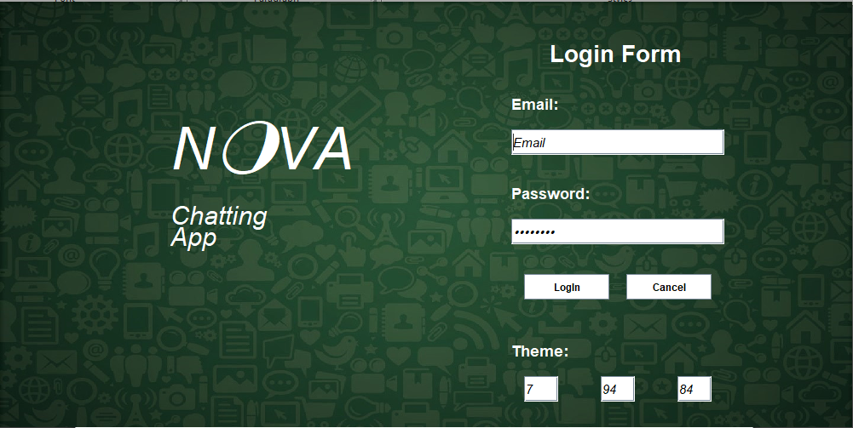

Server

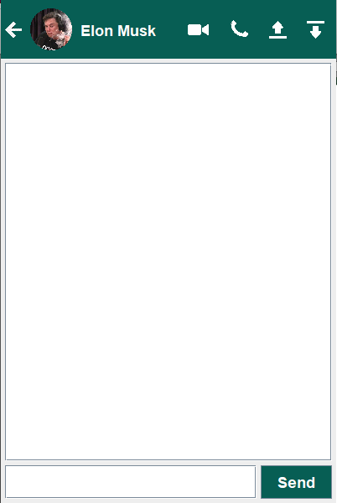

Client:

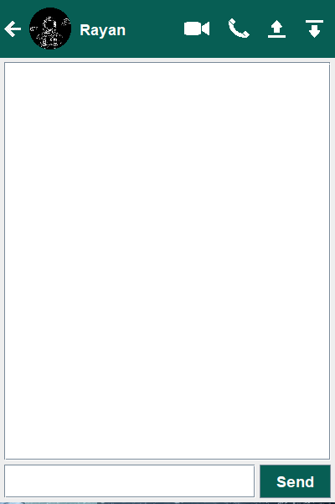

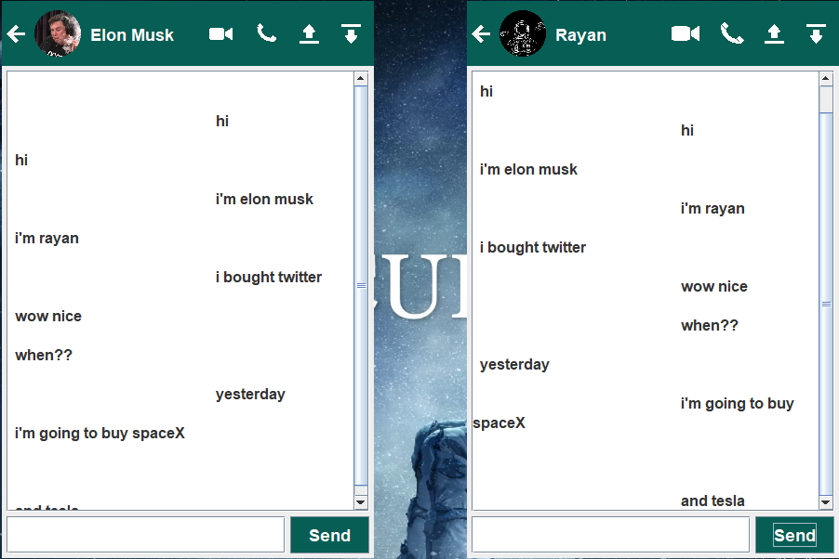

Video Call:

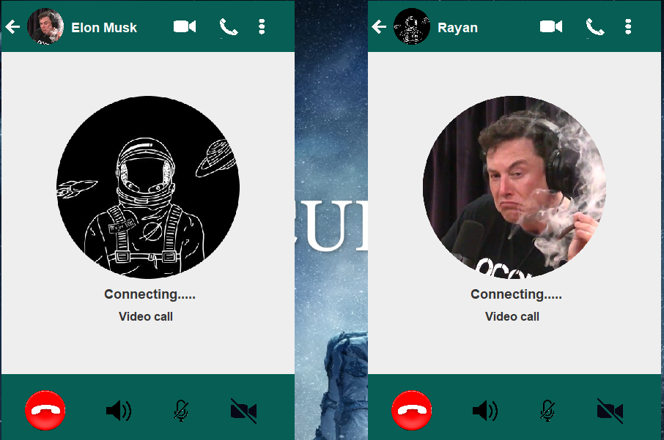

Audio Call:

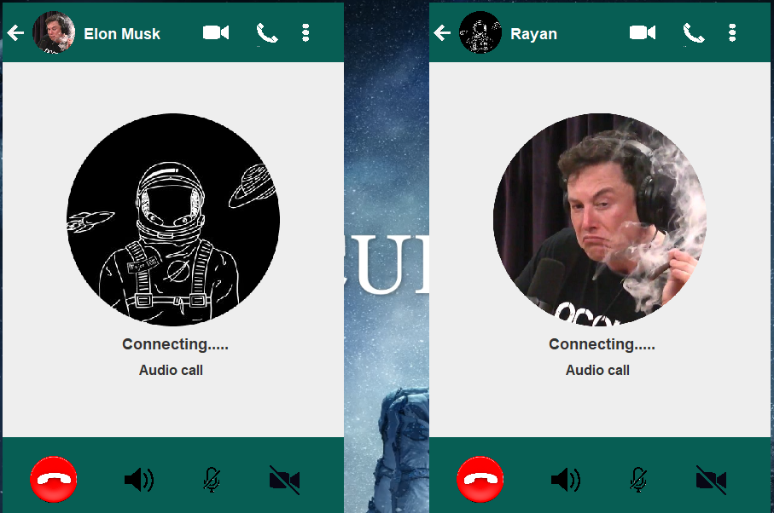

Backed Up Chats:

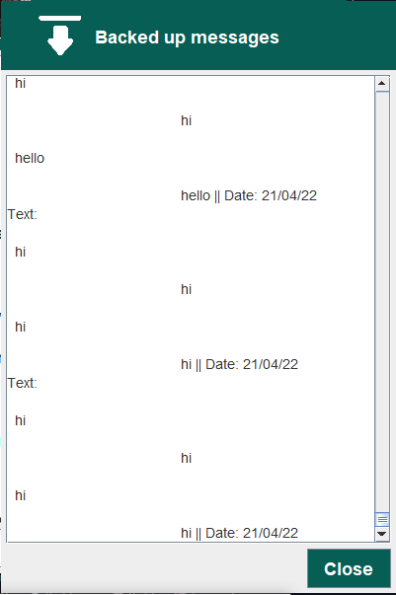

Button to Upload Chats in Database:



User can change the theme by entering desired value here

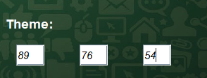

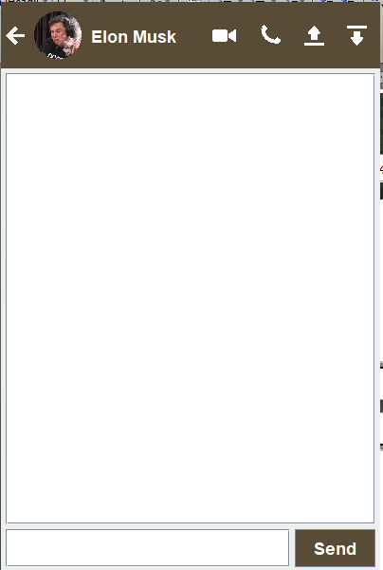

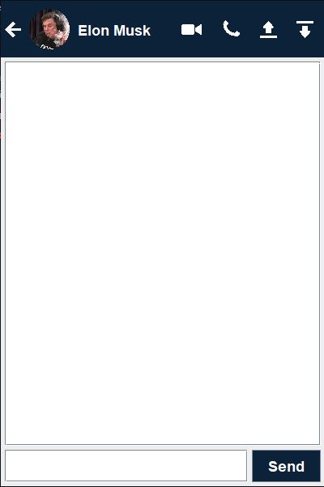

If user enters wrong username or password in login form a error page will be instantiated:

